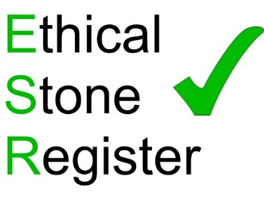
We are delighted to announce that Harrison Goldman have joined the Ethical Stone Register. Following completion of the required questionnaire Harrison Goldman have become the first design consultants to achieve Declaration level on the Ethical Stone Register, providing their clients with the assurance that comes from using an ESR member company. They will join the ever-growing list of companies and stones on the Ethical Stone Register.
Harrison Goldman specialises in all aspects of natural stone consultancy including cladding, paving, flooring, lining, inspections, condition surveys, reports, specifications, stonework layouts, details and fixing designs.
The Ethical Stone Register is a unique resource created specifically for the natural stone industry, in response to The Modern Slavery Act 2015 and the issues of sourcing materials responsibly. The project will allow Stone Federation members, whatever their size, to offer a responsible and manageable ethical sourcing solution to their clients.

There are three tiers of membership of the Register, Declaration, Verification and Accreditation and the requirements of each level are explained below.
Declaration - At this tier, companies will have to complete a questionnaire looking at the responsible and ethical sourcing practices of their business. To achieve this level, a company will need to meet 100% of the criteria. The claims and assertions made by a firm at this level will be by means of self-declaration.
Verification - At this tier, the claims made by a company at the Declaration level will be externally verified. The initial verification will be for the company rather than each material they supply, however, they may choose to have some or all of their stones included at Verification level. This will involve an independent auditor assessing the journey of the material and ensuring that the responsible and ethical sourcing criteria are met the whole way along the supply chain. Only verified stones will appear on the Register itself.
Accreditation - At this tier, members will have met the requirements of the Declaration and Verification tiers, and will be further audited for this level. The aim is to have the scheme recognised and to gain credits within schemes such as BREEAM and LEED at this tier.
www.ethicalstoneregister.co.uk

